

**ShopNest Store Power BI Capstone**

**By Nayan Kasera**

#### **Batch no- DAP-202401-01**

**INDEX**

|  |  |
| --- | --- |
| **QUESTIONS** | **Page no** |
| **Top Categories by Total Price** | **3** |
| **Delayed Orders Analysis** | **3** |
| **Monthly Comparison of Delayed and On-Time Orders** | **4** |
| **Payment Method Analysis** | **4** |
| **Product Rating Analysis** | **5** |
| **State-wise Sales Analysis** | **5** |
| **Seasonal Sales Patterns** | **6** |
| **Revenue Analysis** | **6** |

1. **Top Categories by Total Price:**

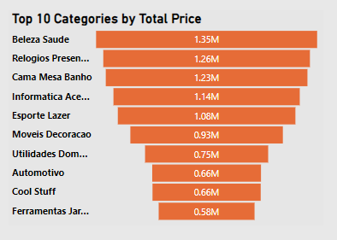

* Beleza Saude have a higiest sales value in among the all category which is 1.35 Million.
* Relogios Presentes is the second hinght price in among all category which is 1.26 Million

1. **Delayed Orders Analysis:**

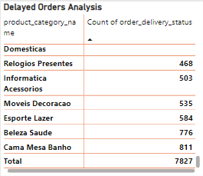 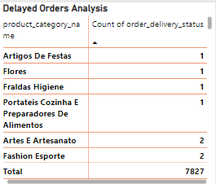

* Cama Mesa Banho has the higiest delay in order which is 811 over the year
* Beleza Saude has the second higiest delay in order which is 776
* Artigos De Festag, Flores, Fraldas Higinne this are the category which have the lowest delay in the order delivery which is 1.

1. **Monthly Comparison of Delayed and On-Time Orders:**

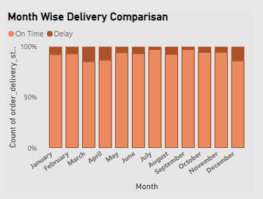

* In the month of march we can see that the there is the highest delay in order which is total 14.58% of the total order which delivery get delayed
* December month also have the second highest delay in order delivery which is 13.84% of total order.
* July month have the highest on time delivery which is 97.67% have the highest on time delivery among the all 12 months.
* March , April and December have the highest delay in delivery which in nearly 15 % of total order.

1. **Payment Method Analysis:**

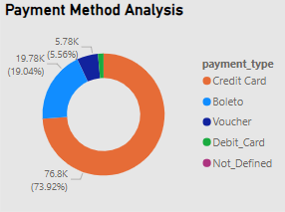

* Credit Card mode have the highestnumber oftransactions which is 76.8K which contribute the 73.92% of total Payment
* Boleto have the second highest mode of payment which contribute the 19.04% of total payment.

1. **Product Rating Analysis:**

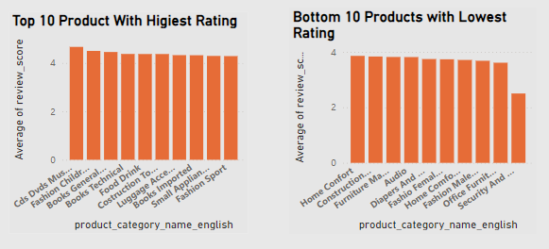

* **Cds Dvds Musical have the highest rating of 4.67 among the all product category.**
* **Security And Service Have the lowest rating of 2.50 among the all product category.**

1. **State-wise Sales Analysis:**

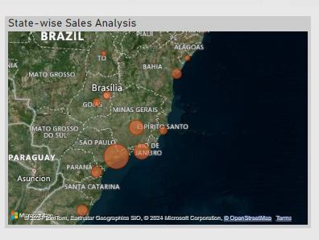

* **State Sao Paulo have the highest sale over the year which is 5.9 Million which contribute the 38.31% of total salaes.**
* **Stare RJ has the second highest sale which contribute the 13.66% of total sales.**
* **State RO has the lowest sales among the all states which only contribute the 0.32 of total sales.**

1. **Seasonal Sales Patterns:**

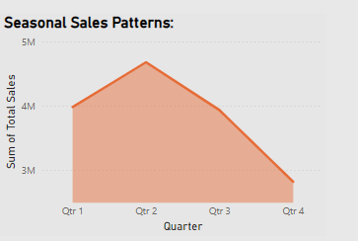

* **During the quarter, sales are showing an upward trend from Q1 to Q2, when they peak in Q2. Following this, sales slightly decline but remain close to the 4M in Q3, before declining once more and falling below the 3M by Q4.**
* **Q2 have the highest sales quarter among the all quarter.**

1. **Revenue Analysis:**

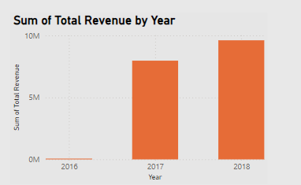

* **The revenue of year 2017 is 7.97M**
* **The revenue of year 2018 is 9.61M**
* **Sales get increase in 2018 by 20.58%.**